PAGE: Index

About us
The UK Centre for Ecology & Hydrology is taking part in the first International Conference of the Global Framework on Chemicals (IC1). Join us at the Action and Partnerships Hub to discover how our scientists bring long-term environmental monitoring, chemical risk assessment and pollution modelling to the conversation, helping to turn the Framework’s targets into measurable progress and actionable insights on the ground.
Healthy environments underpin healthy economies, resilient communities and sustainable growth. Yet understanding whether actions to address pollution are working requires robust evidence that connects data and understanding across air, water, soil and wildlife. The UK Centre for Ecology & Hydrology (UKCEH) works with governments, international organisations and partners to generate, integrate and interpret environmental evidence that supports decision-making on chemicals and pollution.

Find Out More links
- Monitoring chemicals in the environment. How long-term monitoring can track progress against the Framework’s targets.
Links to another page with brief details and links to PBMS and HMS (and other initiatives?)
- Advanced chemical analysis. UKCEH facilities provide high-quality data across a range of contaminants and matrices.
Links to another page with details about:
  - Analytical Chemistry – link to existing page or new description?
  - CoreMiS
  - Microplastics Analysis Facility
Write text below.
- Prioritising actions. Integrated modelling and monitoring to assess the effectiveness of policy options and interventions in reducing pollution.
Sam to write a few paragraphs, maybe draw out intentionally added microplastics example
- Environmental Information Data Centre. Open datasets on chemicals, pollutants and their effects on ecosystem.
Link to EIDC

PAGE: Monitoring chemicals in the environment
Details about PBMS and HMS

PAGE: Advanced chemical analysis

CoreMiS
The Centre for Multimodal Correlative Microscopy and Spectroscopy (CoreMiS) is the first platform in the UK dedicated to micro-spectroscopic analysis of environmental samples by Raman Imaging and Spectroscopy with Scanning Electron Microscopy and Energy Dispersive X-ray Spectroscopy (RISE-EDS).
RISE-EDS allows us to see in tiny detail chemical reactions in water, atmosphere, soil, plants.
Despite the recognition of the common importance of nanoscale phenomena for governing the behaviour of pollutants, scientists to date have relied on measurements made in bulk or at best, at the microscale to infer these critical nanoscale processes. Without nanoscale understanding, it will remain challenging to identify, understand and manage exposure to environmental pollutants and the resulting health and ecological impacts.
[images for any mini page/ section can be found https://www.ceh.ac.uk/solutions/laboratory-services/uk-centre-multimodal-correlative-microscopy-and-spectroscopy-advanced-environmental-science]
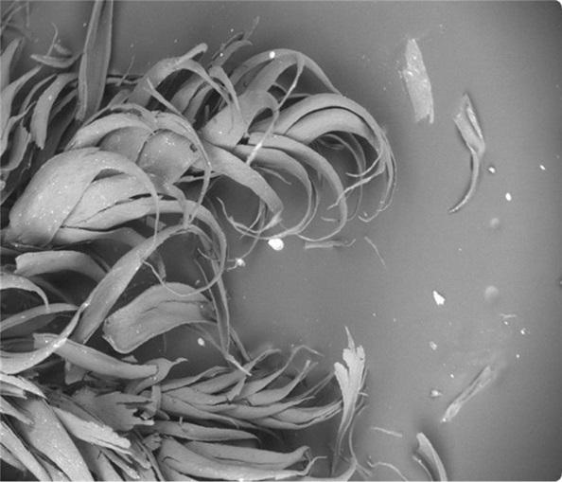

The Microplastics Analysis Facility
The purpose of the Microplastics Analysis Facility is to detect the presence of plastics in the environment so that researchers can understand their fate, bioavailability and interactions with wildlife. This research helps governments, consumers and industry to tackle the growing pollution and harm caused by plastic litter and microplastic particles in the environment - in our soils, freshwaters, oceans and food chains.
The facility has undertaken work across public and private sectors investigating the prevalence of microplastics in our natural world. For example, we identified the widespread deposition of microplastics from the air across rural areas of the United Kingdom, as part of the Working Group on Effects (WGE) of the Convention on Long-range Transboundary Air Pollution (LRTAP). Baseline assessments such as this, and our work investigating microplastics in the UK water industry, are essential in tracking progress against societal, government and industry priorities, to reduce the emissions and potential harm of plastics and microplastics in the environment.

PAGE: Prioritising action
Examples of work assessing policy options. Defra IAM, neonics, SGARs?

